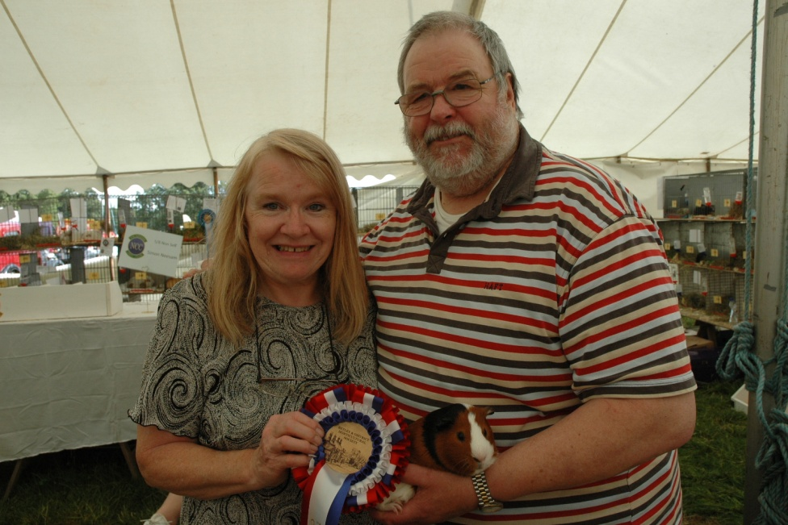
A BRIEF HISTORY of
THE NATIONAL TORTOISE & WHITE CAVY CLUB

Joan & Ken Phillips holding ‘Albert’ after he won Champion of Champions at Betley in 2012
2018 will be the fourth year that Penny Bell and myself have been Joint Secretaries of what we have always believed to be one of the oldest breed clubs in existence today. It has been said that little was known about the club’s history before 1934 when the President was Francis Beetham, Vice President Miss E.J. Tomlyns - Grafton and the Secretary Len Nicholson of Morley, Nr Leeds.
Reading through old copies of Fur & Feather has highlighted many missing links in our club’s history. From a copy dated March 10th 1939 an article written by Mr W Ward was entitled “A Founder member recalls the days of REBELLION IN THE CAVY WORLD.” Mr Ward said that he thought it was about 1904 when “the rumpus started” and more controversy on the variety was written in Fur & Feather than any other”. Mr Ward made a suggestion through Fur & Feather that a specialist club be started for the Tort & Whites and the response was instantaneous and practically all the supporters were NCC members - the year was 1905 (and shortly afterwards the Self Club was founded under the Secretaryship of Mr H. Downs.) Mr Ward goes on to say that he had to make a temporary retirement from cavies due to his business commitments abroad, and that he had to part with his wonderful collection of Tortoiseshells, but his sister would carry on with his Tort & Whites including his old Champion ‘Persimmon’.
Again with reference to Fur & Feather we move on to October 23rd 1908 - TORTOISE & WHITE and BROKEN COLOUR CC. “The former named club is now beginning again, but we are not sure about the name yet. There was much discussion about the Tortoiseshell and suggestions that they should be included or that it should be styled the Broken Colour Club. Going on to say we have few, very few breeders of Tortoiseshells and Brindles and neither of these varieties could support a specialist club entirely on its own, not even if they joined forces. We already have a few members”, says Mr George Burman, secretary from Cleethorpes. He goes on to say in November 1908 that all the members who have written are in favour of a TORTOISE & WHITE CC (with the exception of two) “so I think we can do no other than stick to the premier variety alone”. January 1909 ballot results were published for the reformed TORTOISE & WHITE CAVY Club (15 papers returned).
1922 saw Mr Archie Farrar as Secretary, the membership was then 47 and subscription was 3 shillings and sixpence. Alf Foster, the cavy king was a committee member and Mrs Fernie, the donor of our handsome Fernie Bowl was President. In 1934 at THE BRADFORD 14th ANNUAL CHAMPIONSHIP SHOW Mr Dixon awarded this cup to Mrs Fyfe’s “evenly balanced” adult Boar which was later claimed in the auction for £6.10s by Mr E Brooks! At this show Mr C.A. House gave his views on the cavies and compared them to the cavies of 30 and 40 years ago (1894). One of the things that stood out for him were “the PATCHIES, for richness of colour, sharpness of markings, shape and coat were the best I have ever seen”.
A name that crops up in the Tort & White world frequently in those years is that of Mr William H. Greenlees (Billy) who lived in Davyhulme, Manchester. His name is first mentioned in an advert in C.A. House’s book written in the early 1900s when Billy says he has been a Cavy breeder since 1886 and member of the Tortoise & White CC, NCC and Abyssinian CC. He was Vice President of our club in 1945 and was also President of the National Cavy Club in 1947/8. In January 1941 an article was published in Fur & Feather written by him entitled “The pleasures of breeding Tortoise and White smooth coated cavies”, a very detailed article, full of information which will be published in our club archive. He gives the Secretary at that time as Mr F.C. Davy from Hull and the fact that “during the war the Agricultural shows had not been held and other shows have been limited. Nevertheless, the fancier would be well advised to make a start now by getting a stud together and gaining experience in breeding and looking after Cavies so that he may stand a better chance of a good send-off when the “All clear” goes”.
Mr. F. F. Rogers was appointed Secretary in 1944 and held office until 1959 when Mr. Jack Whitworth from Thornton, Bradford took over and remained Secretary until emigrating to New Zealand in 1977. During the 18 years that Mr Whitworth was secretary he recounts many interesting shows and discussions with cavy friends. One particular show that stands out for him is a club show held in 1938. He had very warm memories of the show, managing a first and two thirds in very distinguished company. Len Nicholson was the judge and entries totalled 95 - 17 in the Adult Sow class and 25 in the Novice class!
After Jack Whitworth emigrated, Rodney Joynston from Leeds took over until 1981 when Mrs Avriel Allen started her term of office, a record breaking 25 years. Mrs Claire England took over the reins from Avriel for seven years and retired at the end of 2013 when Joan & Ken Phillips were asked to take over in an acting capacity until the ballot for 2015/16 when Penny Bell and Joan Phillips became Joint Secretaries.
In the 1980s it was decided to appoint a Chairman and Jim Tenner (of DLC fame) held this position until he became President, when he was followed by Mr George Howard and when he became President Mr Les Petherick was voted Chairman. Les was followed by our present Chairman Mr Graham Godfrey.
Although there is much more research to do I would like to end with a small part of an article written by Jack Airton in 1976 whilst he was Vice President - “When the goddess of fortune does smile on you and I hope she will, there will be plenty waiting to give you a good price for it. If I bred a flyer all the money in the world would not tempt me to part with it.”
THIS IS A POTTED HISTORY OF OUR CLUB AND THERE IS MUCH MORE FOR A LATER DATE.

